Create & Deploy Web App

Step 1: Open Microsoft Azure Portal
https://portal.azure.com

Step 2: Create Web App
+ Create a resource -> Get started -> Web App
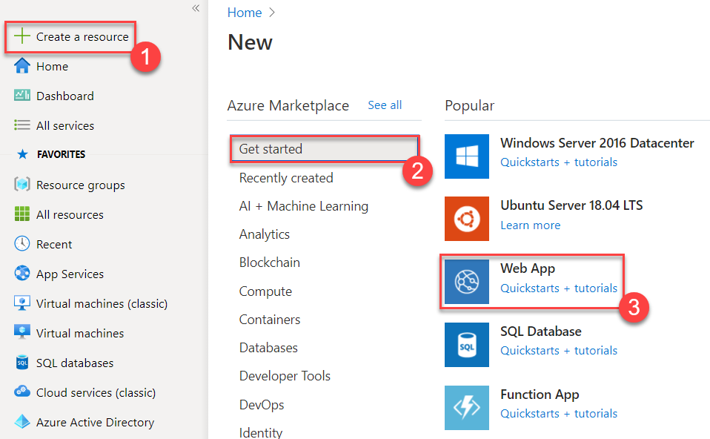

Step 3: Create Web App
Subscription: Choose active Subscription Ex. Azure Pass, Free Trial, etc
Resource Group: Create New Ex. WebAppDemoRG
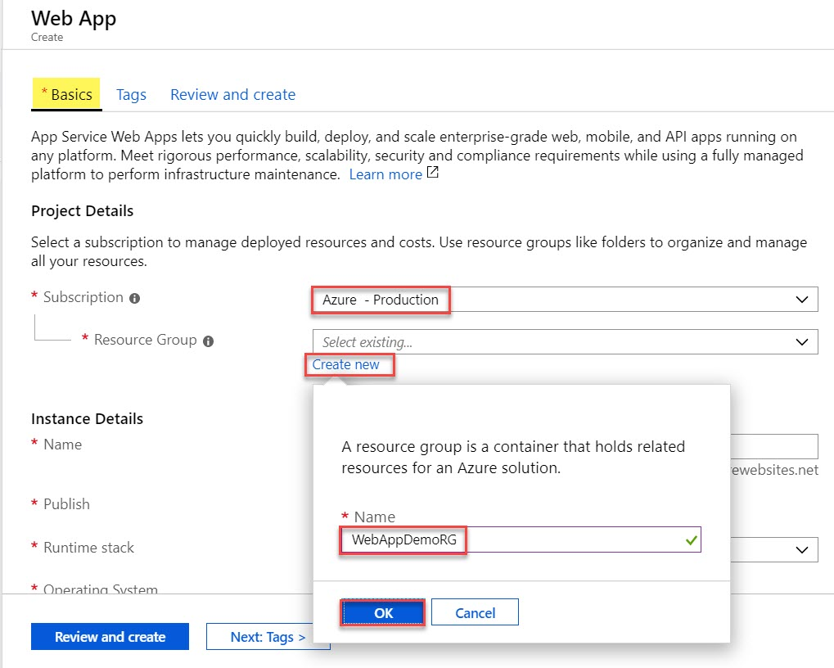

Name: Enter Unique App Name ex. webappdemo
Publish: Code
Runtime stack: ASP.NET V4.8
Operating System: Windows
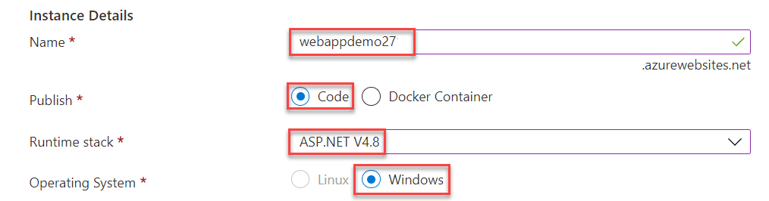
Region: Choose Nearest Region Ex. East US
Window Plan: Create New Ex. webappdemoPlan
Click on OK button.
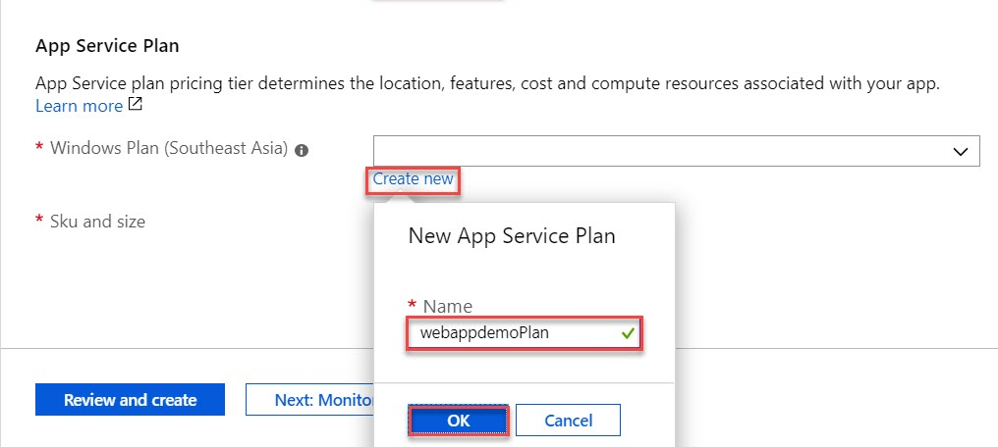

Go with default sku and size
Click on Next: Deployment > button
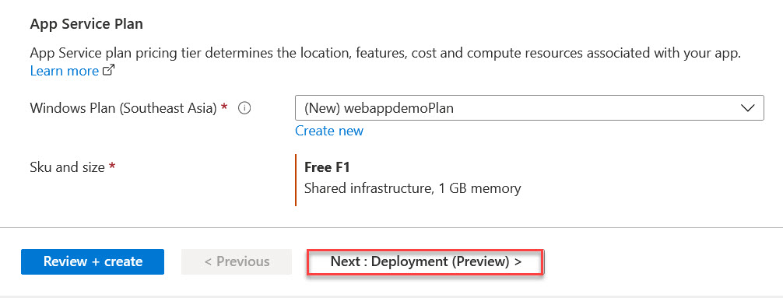

Continuous deployment: Disable
Click on Next: Monitoring >
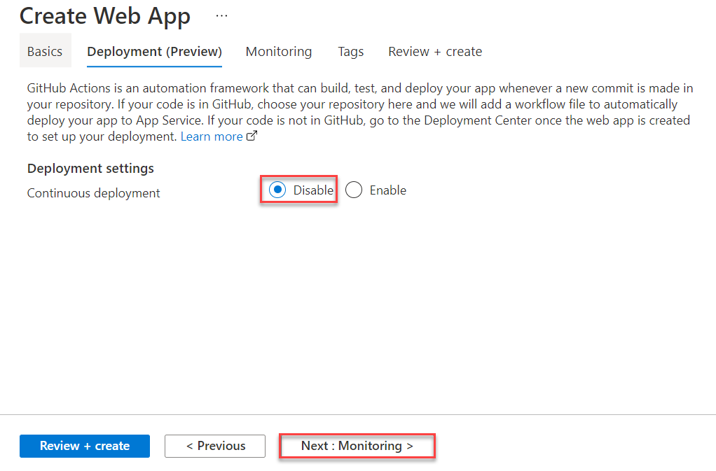

Step 4: Monitoring Tab
Application Insights: No
(Note: For this demo it’s not required but later on for other labs we will enable)
Click on Review and Create button.
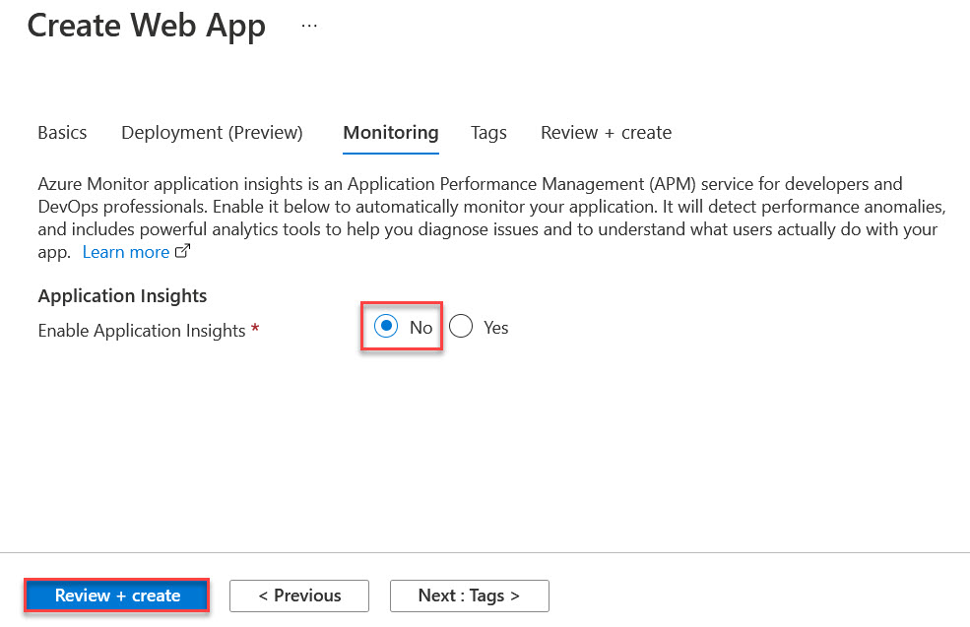

Step 5: Click on Create button.
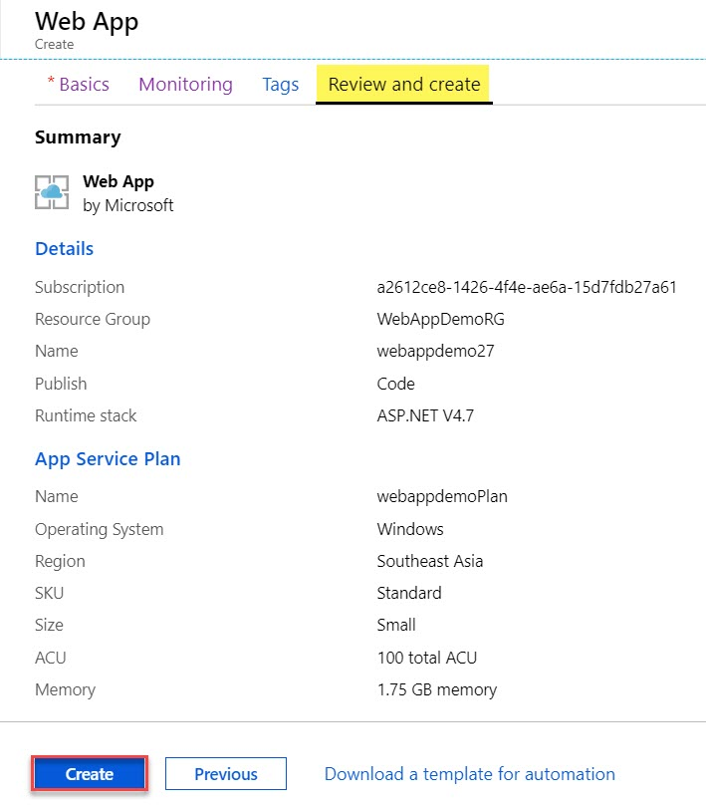
Wait for few seconds to deploy Web App.
Click on Go to resource button.
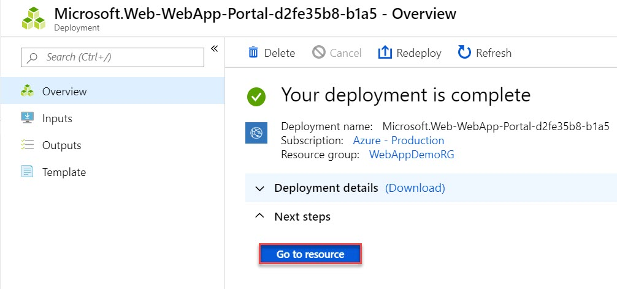

Step 6: Click on Browse option or Copy Web App URL
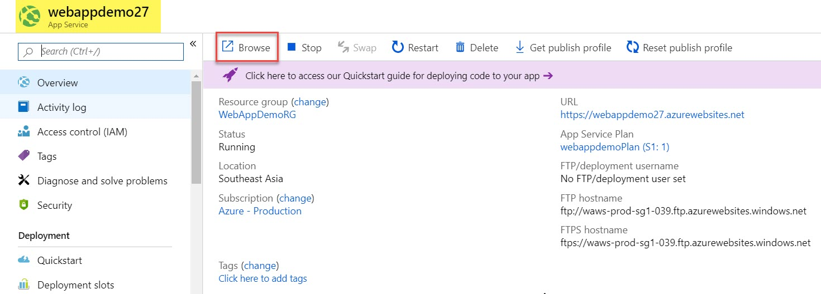

Step 7: Sample Page will run of Azure Web App.
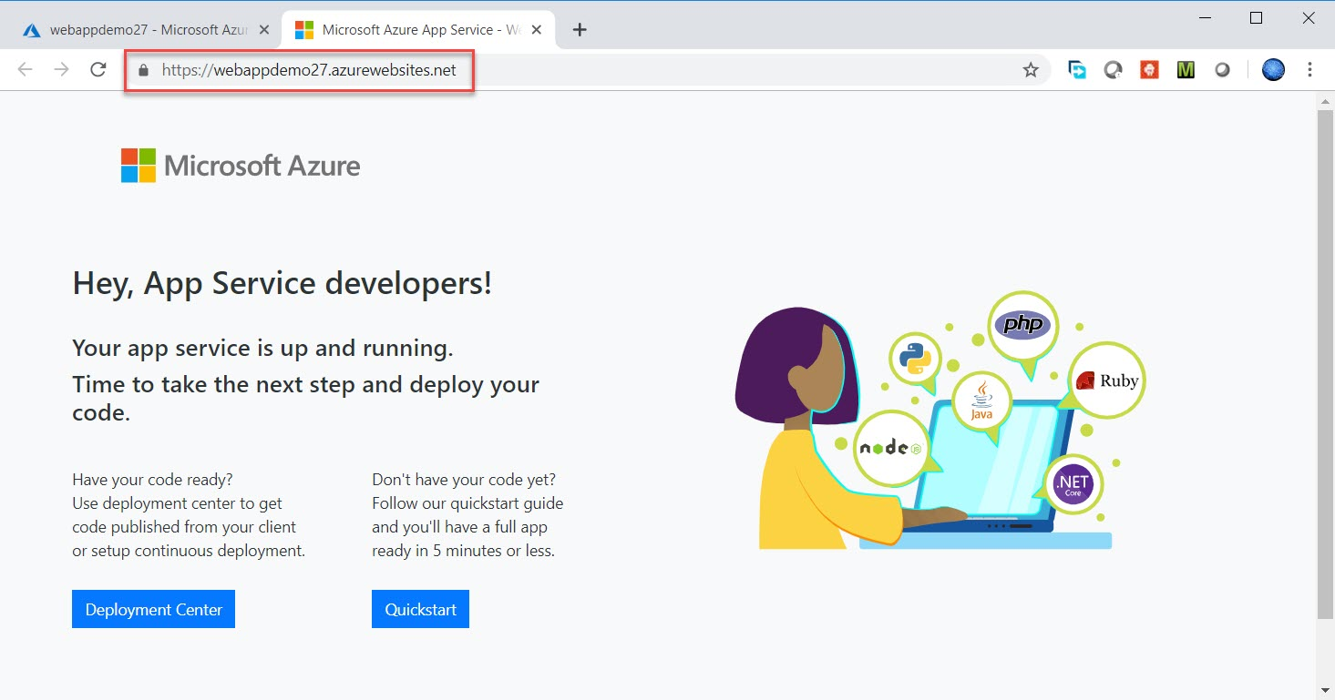

There is multiple way to upload content on Web App but in this document two methods are available.

Method 1: Via Online App Editor option
Step 1.1: Back to Azure Web App blade. Click on Scale Up (App Service Plan) under Settings
Change Plan to Standard S1
Scale up (App Service Plan) - > Production -> Standard S1 -> Click on Apply button
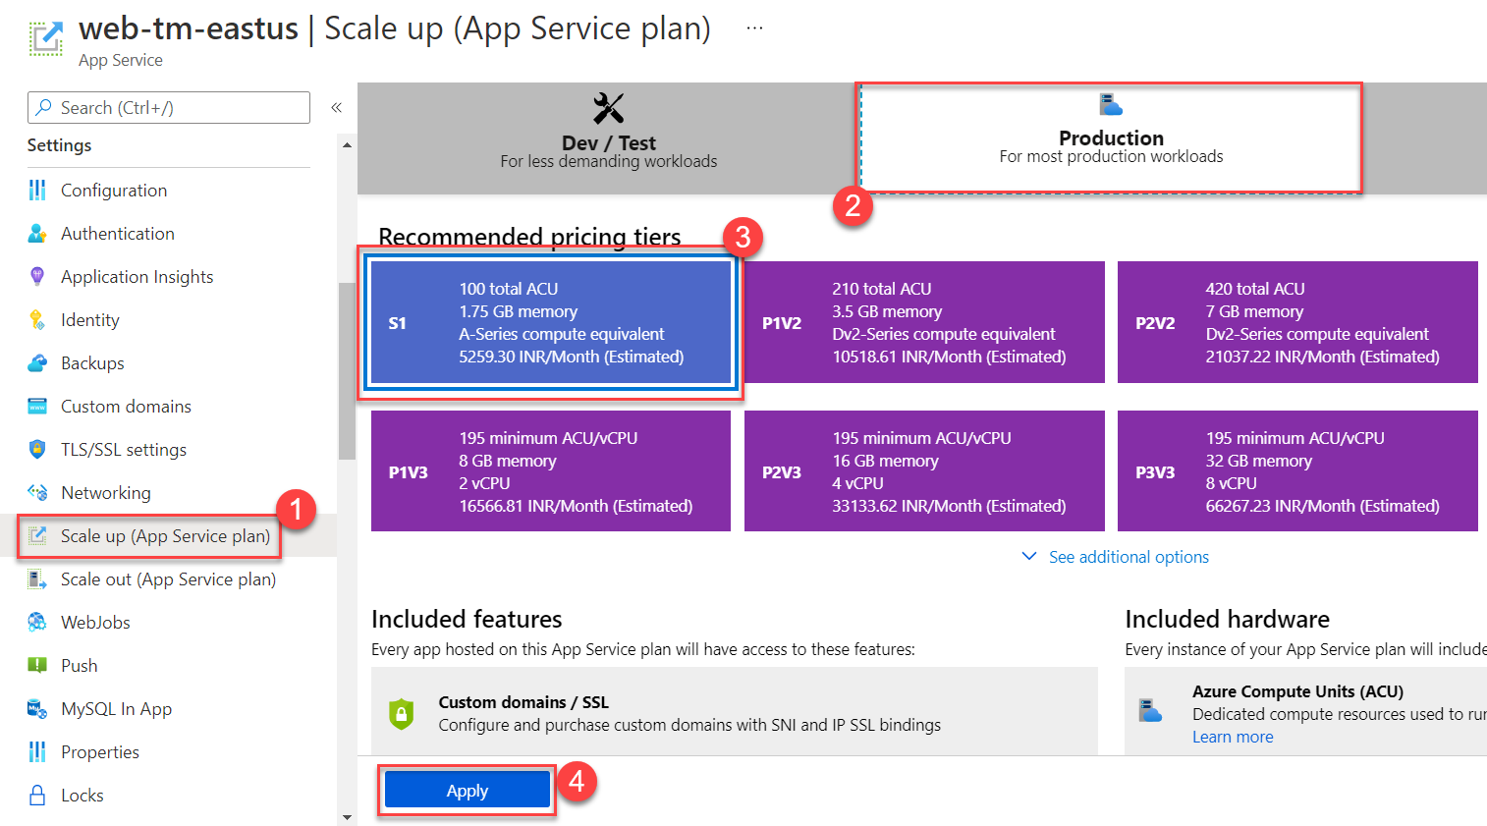

Search for editor or navigate to Development Tools section
Click on App Service Editor (preview) option
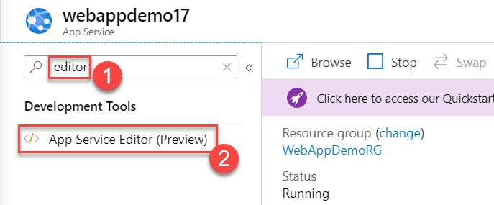

Step 1.2: Click on Go -> option
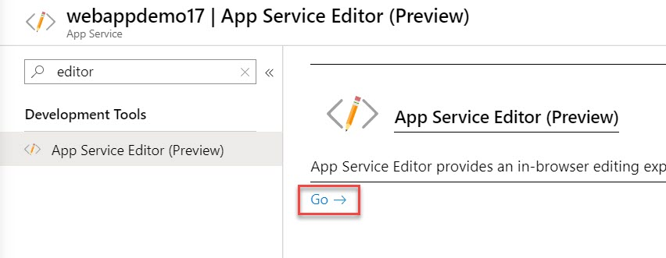

Step 1.3: Select sample page hostingstart.html
Remove all sample code
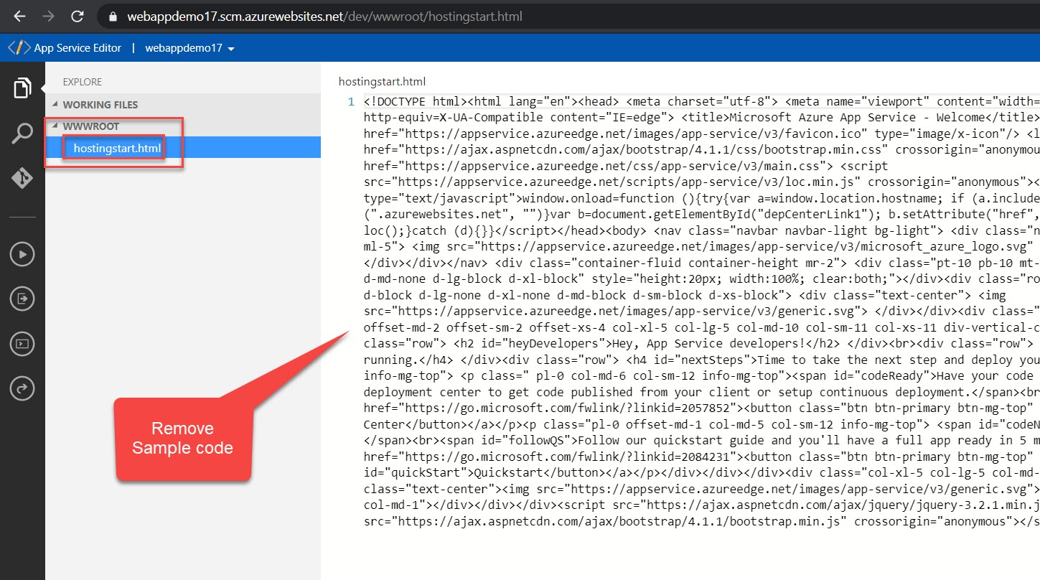

Step 1.4: Update with below code:
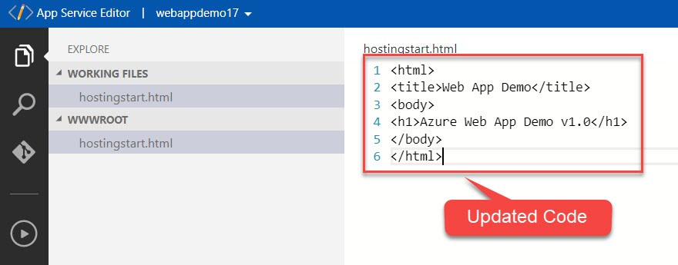
<html>
<title>Web App Demo</title>
<body>
<h1>Azure Web App Demo v1.0</h1>
</body>
</html>
Autosave available with this editor so don’t worry about that.
Step 1.5: Navigate to Azure Portal tab
Select Overview and click on Browse option
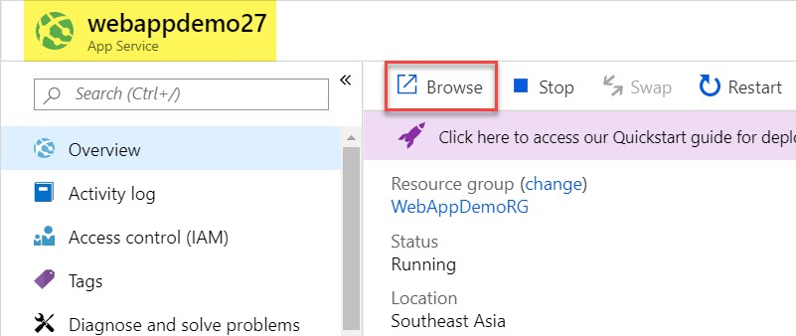

Check updated content
